Skyline High Resolution Metabolomics

The Skyline Targeted Proteomics Environment provides informative visual displays of the raw mass spectrometer data you import into your Skyline documents. Originally developed for proteomics use, Skyline has been extended to work with generalized small molecules. This tutorial explores using Skyline for targeted quantification of small molecules using high resolution data.

In this tutorial, you will learn about Quantification of Polyunsaturated Fatty Acids in Plasma using NIST SRM-1950 as Single-Point External Calibrant, used along with stable-isotope internal standards.

You will explore:

* Use of molecular formula and adducts to assign precursor accurate mass
* Analysis of high resolution accurate mass precursor quantification data in Skyline
* Quantification using Single-Point External Calibration with SIL internal standards and surrogate standards.
* Use of Concentration Multiplier to adjust calibration range for each analyte.

Skyline aims to provide a vendor-neutral platform for targeted quantitative mass spec research. It can import raw data from the instrument vendors Agilent, SCIEX, Bruker, Shimadzu, Thermo-Scientific and Waters. The ability to import data across various instrument platforms greatly facilitates cross-instrument comparisons and large multi-site studies. This remains equally true in using it to target small molecules, as it has been for years in the field of proteomics.

If you have not already looked at the “Skyline Small Molecule Targets” tutorial you should do so now, in order to pick up a few basics about how Skyline works with small molecule descriptions including chemical formulas and adducts.

# Getting Started

To start this tutorial, download the following ZIP file:

https://skyline.gs.washington.edu/tutorials/HiResMetabolomics.zip

Extract the files in it to a folder on your computer, like:

C:\Users\bspratt\Documents

This will create a new folder:

C:\Users\bspratt\Documents\HiResMetabolomics

It will contain all the files necessary for this tutorial. Now start Skyline, and create a new empty document.

## Importing a Small Molecule Transition List into a Skyline Document

The easiest way to get a small molecule transition list into a Skyline document is to start with an empty document and use the **Edit > Insert > Transition List** menu item.

## Transition list insert

To begin, do the following:

* If you are an Excel user, open the provided PUFA_TransitionList.xlsx file. Otherwise, you can open the CSV version PUFA_TransitionList.csv in any text editor.
* On the Skyline **Edit** menu, choose **Insert** and click **Transition List**.

Skyline will show the **Insert** form, which may start out looking like this:

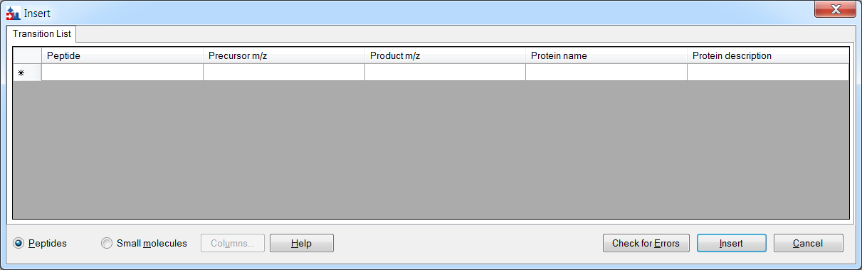

If it does, you can change it to accept small molecule fields by doing the following:

* Click the **Small molecules** option at the bottom of the form.

The form should now look something like this (you may have a different column selection and order from previous uses of Skyline):

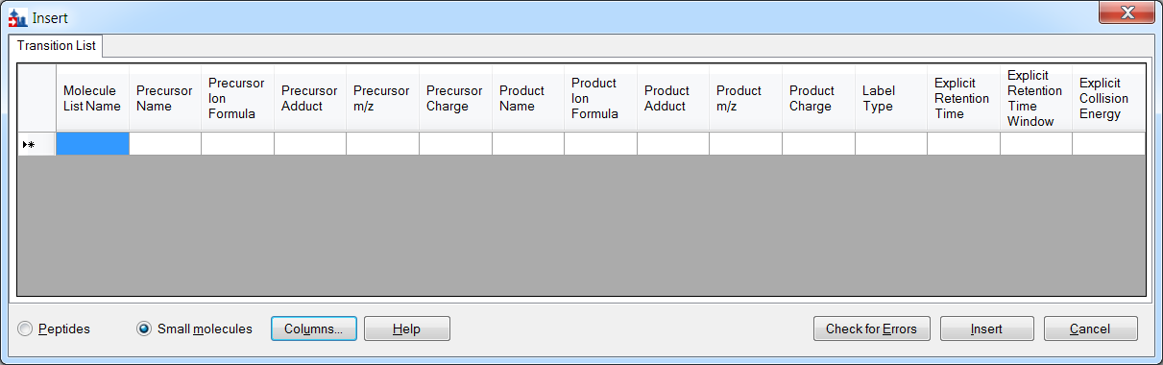

You can see that there are some extra column headers in the **Insert** form, and the column order is not the same in the form as in the spreadsheet. Both issues are easy to correct:

* Click the **Columns** button and uncheck the columns that do not appear in the spreadsheet.

This should result in a column picking menu like the one shown below:

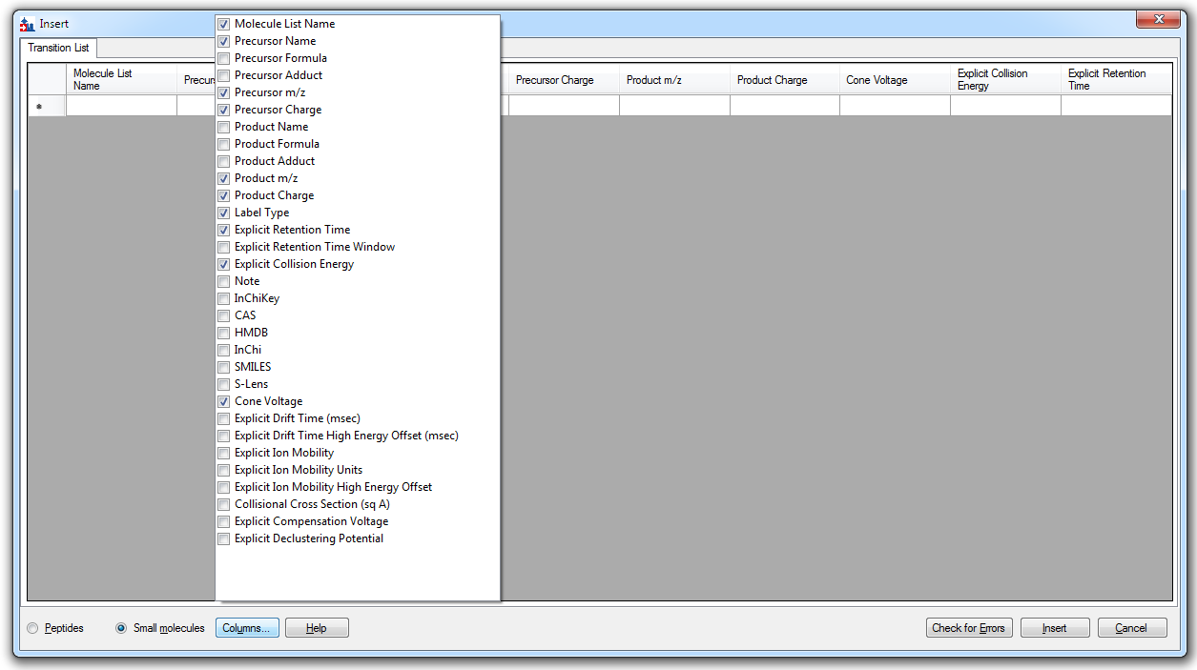

Next do the following to reorder the columns in the **Insert** form:

* Click and drag each column header you want to move to the order matching the spreadsheet.

Once you have selected and arranged your columns, the insert form should now appear as shown below:

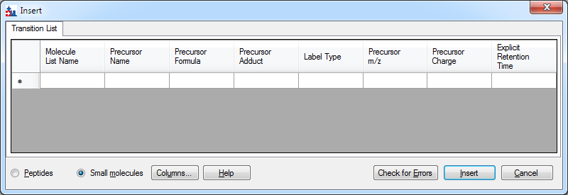

Now:

* Copy the transition list from Excel (or your text editor, for CSV) and paste into the **Insert** form. Make sure to omit the header row.

There is an intentional error in the transition list: charge is given as 1, but the adduct is [M-H]. If you click the “**Check for Errors**” button you will see this:

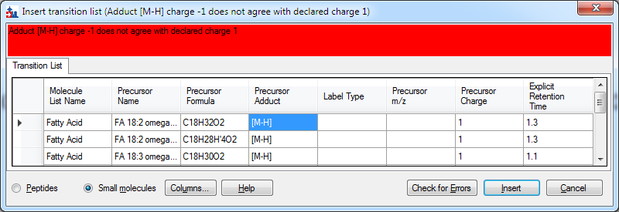

* Change the charge value to -1 in each row and try the “**Check for Errors**” button again.

You will see this:

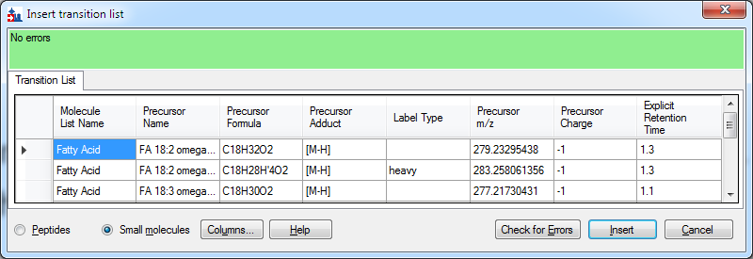

Notice that Skyline has automatically filled in the Label Type column, having determined that the first two entries are a heavy/light labeled pair based on having the same name and formulas that differ only in isotopic labeling (four of the hydrogens are replaced by Deuterium in the second formula).

* Click on the **Insert** button.
* On the Skyline **Edit** menu, click on **Expand All** then click on **Molecules** .

Your Skyline window should now look like this, displaying a tree of polyunsaturated fatty acids which we hope to quantify using high resolution extraction, along with their stable-isotope internal standards (as applicable):

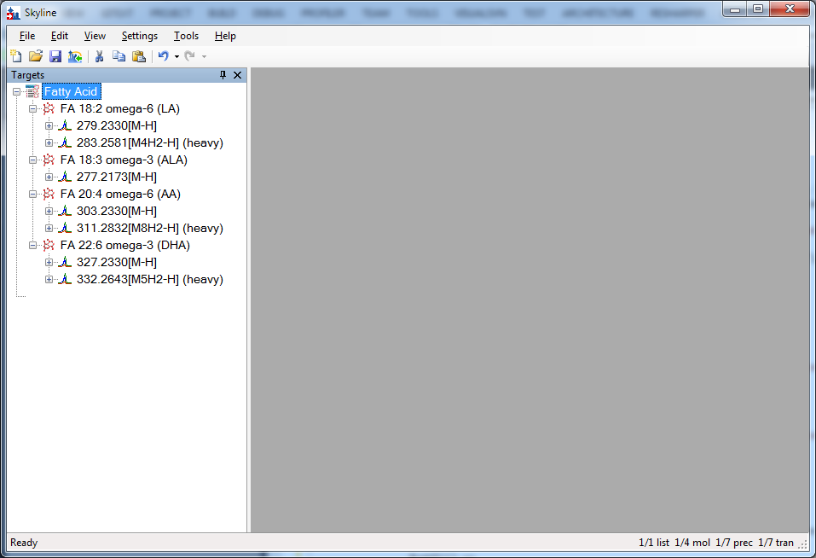

Note that for heavy labeled pairs, the label is expressed as part of the adduct description for the heavy variant. The “[M4H2-H]” adduct tells us that four of the molecule’s hydrogens are replaced by H2 (“M4H2”) and that it is ionized by deprotonation (“-H”).

You will notice that ALA (alpha-linoleic acid) does not have a heavy-labeled variant. Instead, we will assign a different stable-isotope labeled molecule as its surrogate standard. We will use d5-DHA in this case because it is the closest in retention time:

* right-click on the DHA target and choose the “Set Standard Type” submenu
* Click on “Surrogate Standard”

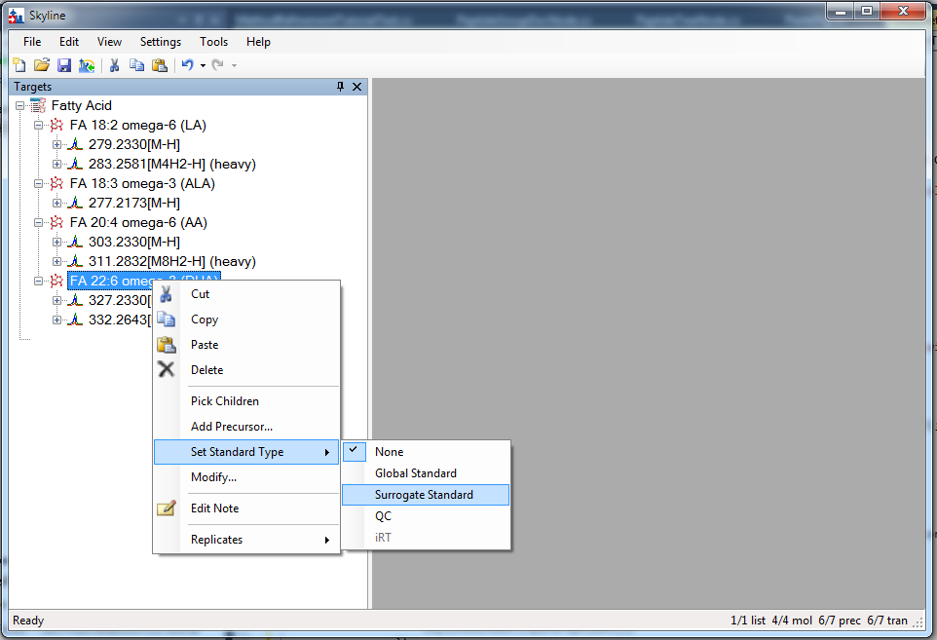

## Transition settings

Next we have to make sure Skyline’s Transition Settings are correctly set for importing the experimental mass spectrometer results. To do this, perform the following steps:

* On the **Settings** menu, click **Transition Settings**.
* Change settings as necessary to match the following:

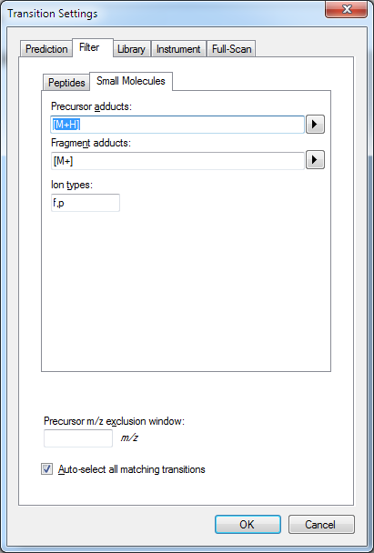 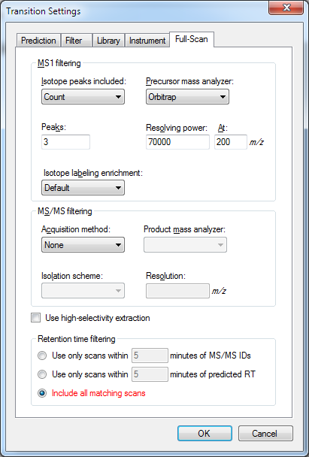

Note: the “f,p” setting in Ion Types on the Filter tab means we are interested both fragment and precursor ion transitions. This Skyline document contains only precursor transitions, but the “f” is harmless.

Now we are ready to import the experimental mass spectrometer results.

## Importing mass spectrometer runs

Perform the following steps.

* On the **File** menu, click **Save**. (Ctrl-S) Save this document as “SM_HiRes_v1.sky”
* On the **File** menu, select **Import** and click on **Results**.
* In the **Import Results** form, choose to import single-injection replicates. For best performance, be sure to select “Many” in the “Files to import simultaneously” control at the bottom of the form. Now click the **OK** button.
* Select all 16 raw data folders in the tutorial folder by clicking the first listed and then holding down the Shift key and clicking the last.

The **Import Results Files** form should look like:

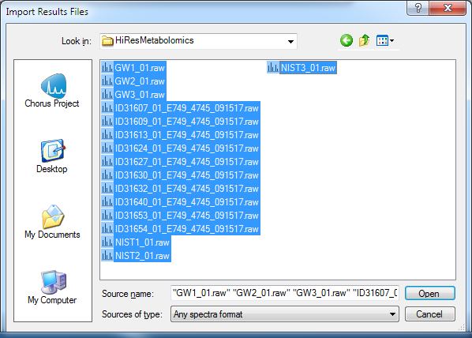

* Click the **Open** button.

The files should import within 30 seconds or so, leaving your Skyline window looking something like this:

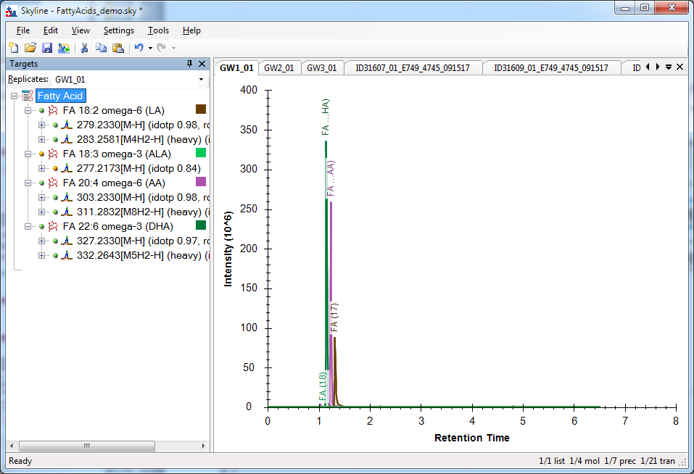

To take advantage of the Skyline summary graphs for viewing individual targets, do the following:

* On the **View** menu, choose **Peak Areas** and click **Replicate Comparison**.
* On the **View** menu, choose **Retention Times** and click **Replicate Comparison**.
* Click and drag these views to dock them above the chromatogram graphs.
* On the **View** menu, choose **Document Grid.**
* In the **Document Grid** view, click on the **Views** control and select **Peptide Quantification**.
* Click and drag the **Document Grid** view and dock it next to the chromatogram graphs.

The Skyline window should now look something like this:

# 

# Checking Peak Integration

Looking at the **Retention Times – Replicate Comparison** window we can see by the lack of outliers that Skyline did not have any problems with peak integration.

# Preparing for ‘Single Point Quantification’

* On the **Settings** Menu, click on **Peptide Settings.**
* Click on the **Quantification** tab.
* Modify the settings as needed to look like this:

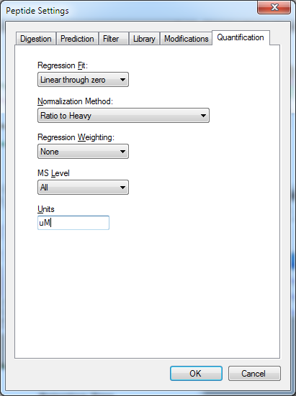

* Click on **OK.**

Now, returning to the **Document Grid** view:

* Click on the **Views** control and select **Replicates**.
* This step establishes the role of each of the samples (‘replicates’) in the study, as standards, unknowns, or quality control samples. Edit the sample types and analyte concentrations as necessary so the view looks like this:

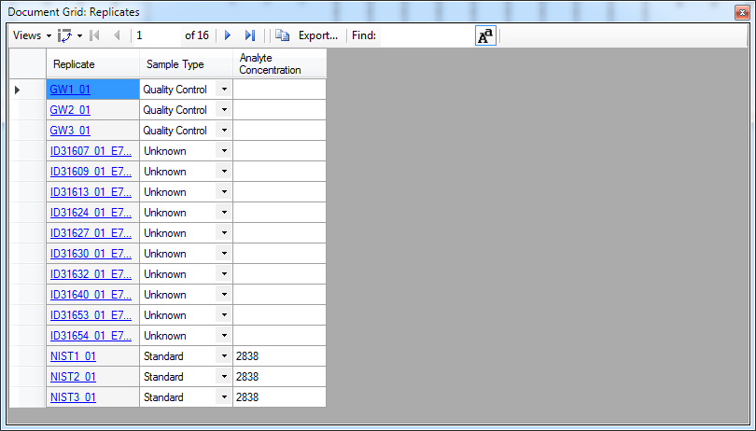Note that in this situation, the concentration given for the NIST sample (NIST-SRM-1950) is the published consensus concentration for FA 18:2 in this reference material, which incidentally is the highest concentration of any analyte in the document. Therefore, in the next step, the concentration multipliers will each be <1 in order to adjust the target concentration of those analytes to their respective NIST SRM-1950 reference values.

* In the **Document Grid**, click on the **Views** control again and select **Peptide Quantification**.
* Set the concentration multiplier and normalization method for each target to match this:

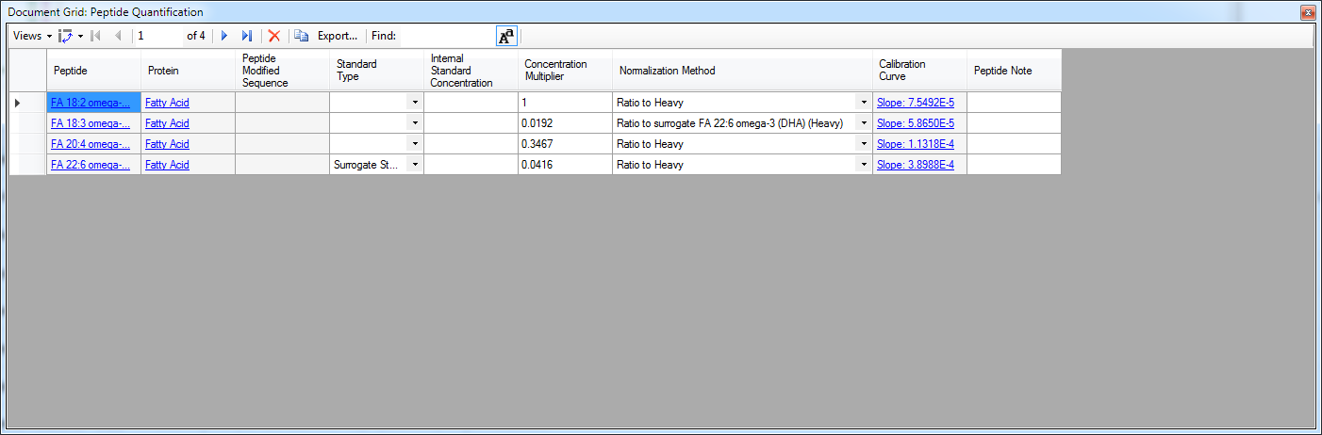

The default normalization method is “ratio to heavy” when using stable-isotope internal standards, but we need to set the FA 18:3 analyte to use the previously-defined surrogate standard as the denominator in the light/heavy ratio.

## Inspect the Calibration Curves

Each entry in the **Calibration Curve** column is a clickable link that brings up the calibration curve view for the molecule in that row.

* Click on the calibration curve link for FA 18:2 and the **Calibration Curve** view will appear:

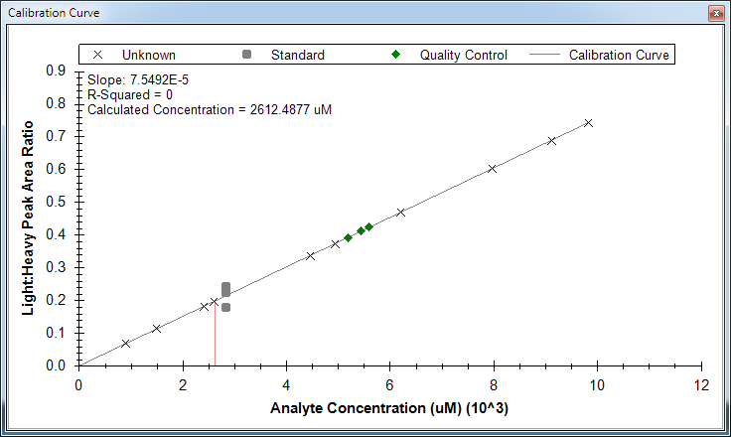

Note that the calibration curve by default has a slope =1 and an intercept = 0, as defined by the method of quantification (**Settings** menu, **Peptide Settings**, **Quantification** tab) and the use of a single point of external calibration. The **Document Grid** or **Report Grid** can be used to export quantitative data (in micromolar) for each sample analyzed.

# Conclusion

In this tutorial, you have learned how to create a Skyline document that targets small molecules specified as precursor ion chemical formulas and adducts. You imported a multi-replicate data set collected on a Q Exactive orbitrap mass spectrometer for a set of plasma samples, , and saw how many existing Skyline features created initially for targeted proteomics use can now be applied to small molecule data. Small molecule support is still a relatively new feature area for Skyline. As such, you can expect it to continue improving rapidly.

# Bibliography